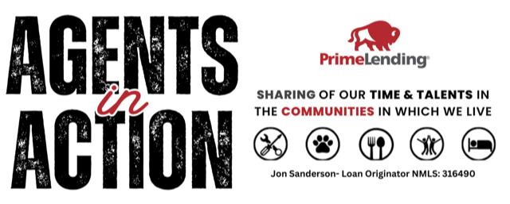  our mission  Agents in Action was created to give Realtors and real estate professionals the opportunity to:  - Serve meaningful non-profits in our local communities  - Experience different causes through hands-on volunteering  - Discover organizations and missions they may grow passionate about  - Build genuine relationships with like-minded professionals  By hosting volunteer opportunities at various locations throughout the year, our goal is to expose participants to a wide range of community needs — allowing each person to find where they feel most called to invest their time and talents.  WHY AGENTS IN ACTION MATTERS  🤝 Community Impact  Every event directly supports a local non-profit and the people they serve.  ❤️ Purposeful Giving  We believe service is most powerful when it’s personal. Exposure leads to passion—and passion leads to sustained impact.  🏡 Professional Fellowship  Agents in Action creates space for meaningful connection among real estate professionals who share a heart for giving back.  📸 Community Promotion  Participants are encouraged to share their involvement on social media— to highlight the importance of community service and inspire others to get involved.  When  June 8th  8pm – 12pm  Where  Student Union Auditorium  1234 Academic Circle, Berkeley, CA  FEATURING · Band Name 1 · Band Name 2 · Band Name 3 · Band Name 4 · Band Name 5 · Band Name 6  web address | MORE THAN  VOLUNTEER EVENT  Our hope is that through Agents in Action:  - Friendships are formed  - Partnerships grow naturally  - Service becomes a shared value in the real estate community  - Giving back becomes a regular part of professional life  THANK YOU  Thank you for  showing up!  Thank you for serving!  Thank you for being  part of Agents in  Action!  Together, we can  make a lasting difference — one act  of service at a time.  Instagram:  Agents in Action –  agents1naction

